**Pratice Making A Humidity Temperature Sensor**

*Damar Lintang Priyatama*

*Fakultas Vokasi, Universitas Brawijaya*

*Email:* [*damarpriya138@gmail.com*](mailto:damarpriya138@gmail.com)

**Abstract**

The project demonstrates the simulation and application of an ESP32 microcontroller interfaced with a DHT22 sensor for monitoring environmental parameters such as temperature and humidity. The sensor data is collected and processed using Arduino programming. The DHT22 sensor, connected to the ESP32 through digital pin 27, provides real-time readings of temperature in both Celsius and Fahrenheit, along with the corresponding humidity levels. The code utilizes the DHT library to facilitate sensor communication, while the microcontroller outputs the data to a serial monitor for easy visualization. Additionally, the heat index is computed both in Celsius and Fahrenheit, providing insights into the perceived temperature under varying humidity levels. The system's reliability is ensured by checking for any sensor read failures, which would prompt the system to attempt another reading. This setup serves as a foundational example for integrating environmental sensors with the ESP32 platform for IoT applications, especially in home automation, weather monitoring, and other environmental control systems.

*Keywords—* *ESP32, DHT22, temperature sensor, humidity sensor, Arduino.*

**1. Introduction**

**1.1 Background**

One of the most commonly used sensors for measuring environmental parameters is the DHT22, a digital sensor designed to measure both temperature and humidity with reasonable accuracy. The DHT22 sensor, combined with the ESP32 microcontroller, offers a simple yet effective solution for monitoring environmental conditions in real-time. The data collected from the sensor can be used to compute additional parameters such as the heat index, which provides a more accurate representation of how hot it feels in a given environment, considering both temperature and humidity.

This project aims to demonstrate the integration of the DHT22 sensor with the ESP32 microcontroller for the purpose of real-time environmental monitoring. The system will read temperature and humidity values, compute the heat index, and display the data via a serial monitor. By doing so, this project highlights the potential of using the ESP32 in combination with environmental sensors for IoT-based applications, offering users valuable insights into the environmental conditions around them.

**1.2 Purpose Experience**  
The purpose of this experiment is to explore the integration of the ESP32 microcontroller with the DHT22 sensor for real-time environmental monitoring, focusing on temperature and humidity measurement. The experiment aims to demonstrate how the DHT22 sensor can be effectively interfaced with the ESP32 to collect and display temperature in both Celsius and Fahrenheit, as well as humidity values. Additionally, it aims to showcase how the heat index can be calculated, combining both temperature and humidity to give a more accurate representation of how hot it feels in a given environment. This experiment will also provide insight into the process of handling sensor data, reading from the sensor, and troubleshooting issues such as sensor read failures. Furthermore, it aims to highlight the use of the serial monitor for visualizing real-time data, making it easier to monitor and analyze environmental conditions. Through this hands-on experiment, participants will gain a deeper understanding of sensor integration and data handling, which forms the basis for developing IoT-based applications. This knowledge can be extended to more complex systems in areas such as home automation, weather monitoring, and agricultural applications, where real-time environmental data is crucial for decision-making.

**2. Methodology**

**2.1 Tools & Materials**

-Laptop Asus

-Vscode

-Arduino IDE

-ESP32 Board Support

**2.2 Implementation Steps**

**-**Open Arduino IDE and choose ESP32 for Humidity Temperature Sensor

-Arrange the ESP32 framework by adding DHT22

-After that connect the cables according to int and GND

-Type the code like this in main.c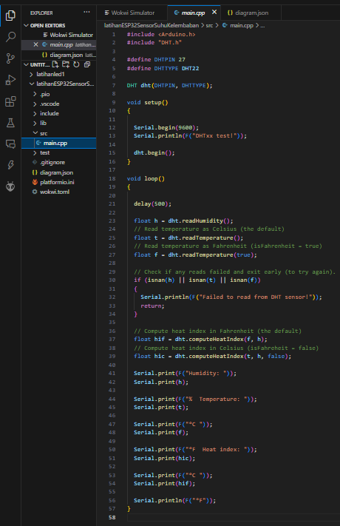

-If it can be run and the results come out and the temperature can be adjusted then the project is complete and successful

**3. Results and Discussion**

**3.1 Experimental Results**

* Diagram.json fromHumidity Temperature Sensor

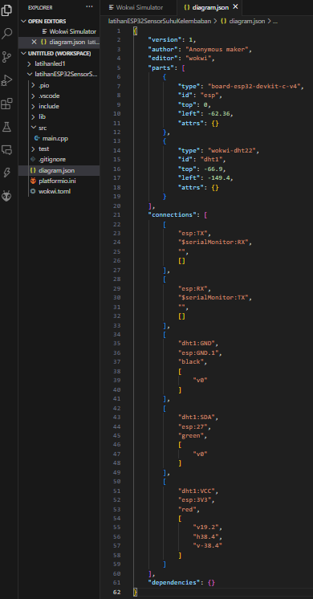

* 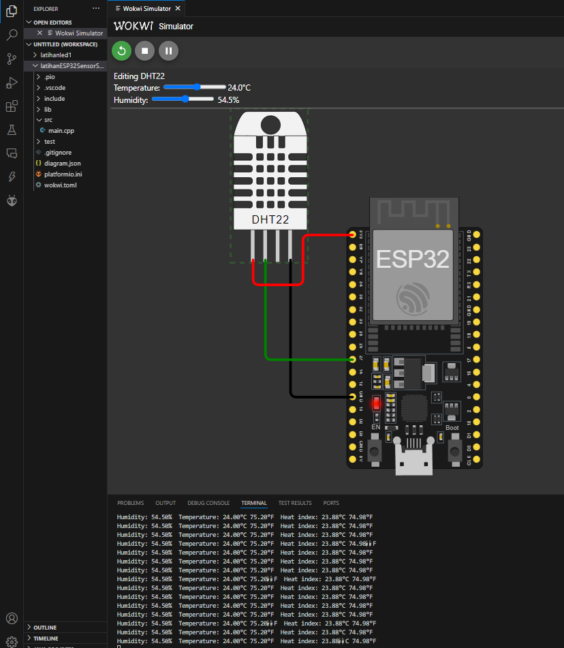Result from Humidity Temperature Sensor